**Assignment No 01**

**Spring 2024**

**CSE-204**

**Operating System**

Submitted by: **NAVEED AHMAD**

Registration No.: **22PWCSE2165**

Class Section: **B**

“On my honor, as student of University of Engineering and Technology, I have neither given nor received unauthorized assistance on this academic work.”



Submitted to:

Dr. Madiha Sher

March 26, 2024.

Department of Computer Systems Engineering

University of Engineering and Technology, Peshawar

1. **QUESTION:** How does a computer's architecture influence its ability to multitask effectively, and what are some real-world examples where understanding this architecture is crucial for optimizing task performance?

**ANSWER:** A computer's architecture, especially its CPU design, is instrumental in determining its multitasking capabilities. For instance, multi-core processors enable computers to handle multiple tasks simultaneously by distributing the workload across different cores. Additionally, features like hyper-threading allow each core to manage multiple threads concurrently, further enhancing multitasking efficiency. Understanding this architecture is vital for optimizing task performance in various scenarios. In server environments with concurrent user access, a robust multi-core CPU ensures smooth operation without performance degradation. Similarly, in gaming, where tasks like rendering and AI processing occur concurrently, a powerful CPU with multiple cores guarantees seamless gameplay without interruptions. Moreover, in data centres managing diverse workloads, an efficient multitasking architecture ensures optimal resource utilization and application responsiveness, leading to enhanced efficiency and cost-effectiveness. Overall, grasping a computer's architecture enables the design of efficient software, effective resource allocation, and maximization of multitasking performance across different applications and industries.

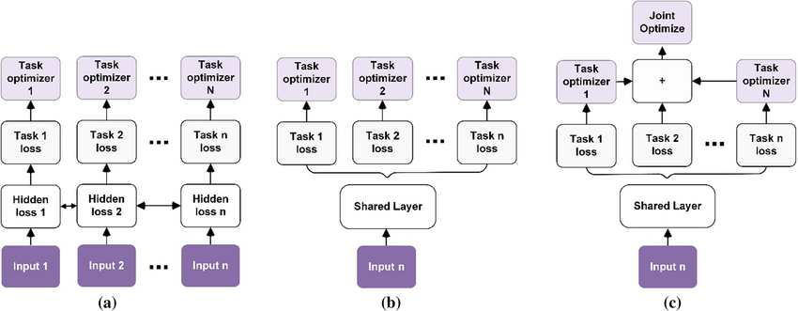

Multitask architecture models.

* Soft training: where each task has its own parameters and model, this is distance regularized to encourage distances to be similar.
* Alternate training: this model allows sharing of information between tasks,
* Joint training: this model allows different parts of the model to share parts of their structure in addition to data statistics.

1. **QUESTION**: How do operating system operations like file management and memory allocation impact the user experience on a day-to-day basis, and what are some common challenges users might encounter if these operations are not efficiently handled by the OS?

**ANSWER:** Operating system operations like file management and memory allocation have a direct impact on the user experience. Efficient file management ensures users can access, organize, and manipulate their data easily, while proper memory allocation ensures smooth application performance.

If these operations are not efficiently handled by the OS, users may face challenges such as difficulty in finding files, which wastes time and reduces productivity. Moreover, inefficient memory allocation can lead to system slowdowns, freezes, or crashes, disrupting the user experience and causing frustration.

In essence, efficient file management and memory allocation are crucial for providing a seamless user experience, and any inefficiencies in these operations can result in decreased productivity and frustration for users.

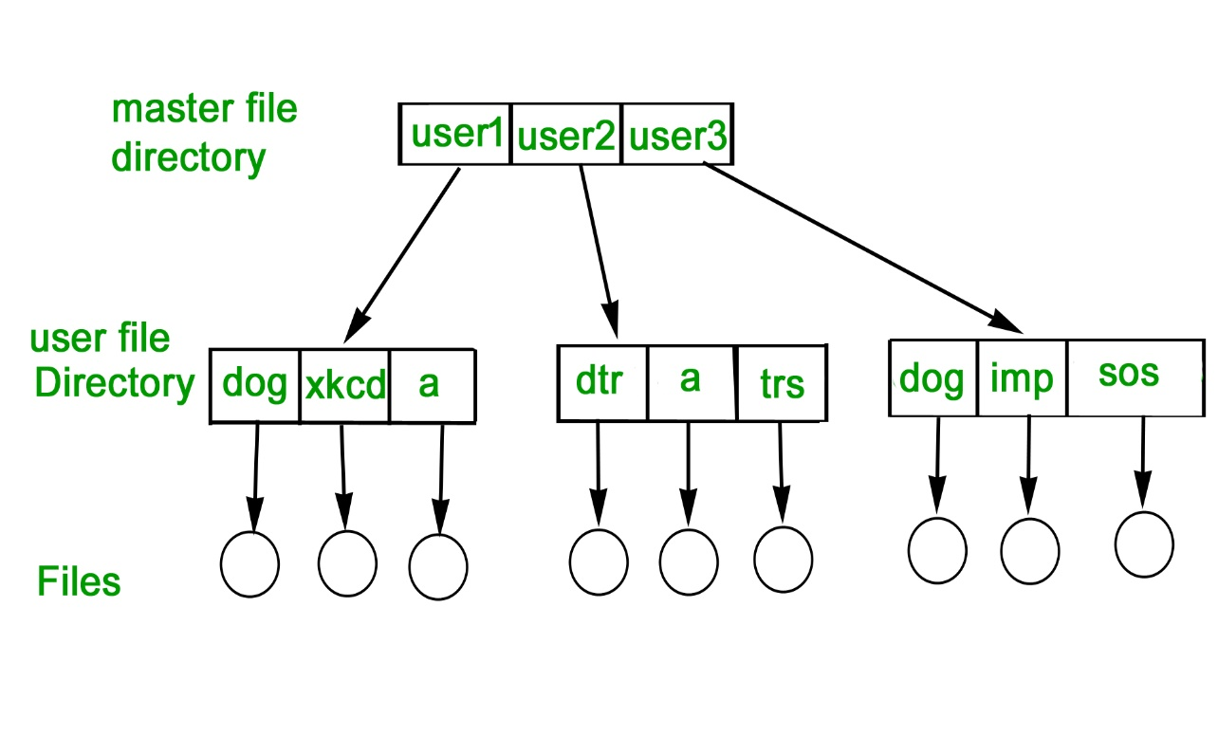

*File system in operating system.*

1. **QUESTION:** How does the design of the user interface impact the accessibility and usability of operating systems for diverse user demographics, and what are some strategies employed by OS designers to improve user interaction and workflow efficiency?

**ANSWER:** The design of the user interface (UI) significantly impacts the accessibility and usability of operating systems across diverse user demographics. A well-designed UI considers factors such as ease of navigation, clarity of presentation, and customization options to accommodate different user preferences and needs. OS designers employ various strategies to improve user interaction and workflow efficiency, including intuitive menu structures, visual cues for guidance, keyboard shortcuts for power users, and accessibility features such as screen readers and voice commands. By prioritizing user experience and incorporating user feedback, OS designers strive to create interfaces that are inclusive, user-friendly, and conducive to efficient task execution for all users.



Design And Development Strategies To Provide Better Accessibility And Animation Using UX/UI

1. **QUESTION:** In what ways do system calls bridge the gap between user applications and the operating system, and why are they essential for enabling functionalities such as process execution, file manipulation, and hardware control?

**ANSWER: System** calls serve as an interface between user applications and the operating system, facilitating communication and enabling access to OS resources and functionalities. When a user application requires OS services such as process execution, file manipulation, or hardware control, it makes requests to the OS through system calls. System calls handle tasks such as memory allocation, input/output operations, and device management on behalf of user applications, ensuring proper resource utilization and security enforcement. By abstracting complex OS functionalities into simple interfaces, system calls shield user applications from the intricacies of the underlying hardware and software, promoting portability and interoperability across different computing environments. Thus, system calls are essential for enabling diverse functionalities within user applications while maintaining system integrity and security.

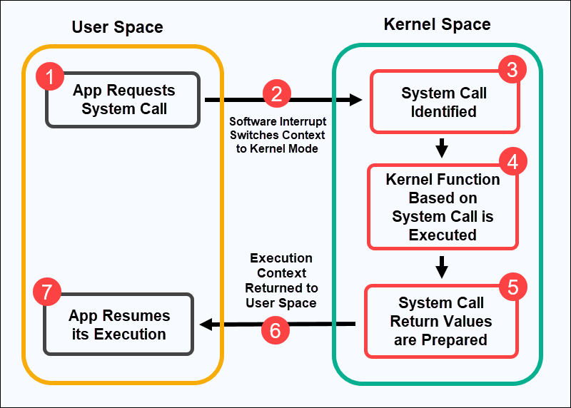

System call

1. **QUESTION:** How do operating system design and implementation impact system performance and user experience?

**ANSWER:** Operating system design and implementation significantly influence system performance and user experience. A well-designed and efficiently implemented operating system can optimize resource utilization, minimize latency, and enhance overall system responsiveness. This directly translates into a smoother and more responsive user experience, with faster application loading times, quicker response to user inputs, and reduced system downtime. Conversely, poor design choices or inefficient implementation can lead to performance bottlenecks, system crashes, and user frustration. Therefore, careful consideration of design principles and implementation strategies is crucial for delivering a reliable and high-performance operating system.

